Self-efficacy

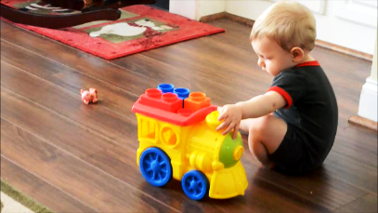
“Self-efficacy is the belief in one’s abilities to organize and execute the sources of action required to manage prospective situations. “ – Albert Bandura, 1986
Used with permission. TW Moore, 2012

The above qutoation is from one of the most influential psychologists of all time, Albert Bandura, of Stanford University. While developing his social learning theory and his emphasis on the role of human thought patterns in understanding behavior, Bandura recognized the importance of self-beliefs in the determination of human action. Self-efficacy is “the belief that one can master a situation and produce favorable outcomes” (Santrock, 2012). Albert Bandura (2010) states that “self-efficacy is a critical factor in whether or not students achieve.” Self-efficacy is the belief that “I can”; helplessness is the belief that “I cannot.” In the view of Dale Schunk (2011), self-efficacy influences a student’s choice of activities. Students with low self-efficacy for learning may avoid many learning tasks, especially those that are challenging. High self-efficacy students readily work at learning activities (Schunk & Zimmerman, 2006) by expending effort and persisting longer than their low self-efficacy classmates (Santrock, 2012).

Self-efficacy is a different concept from self-esteem. The chart below contrasts the two ideas:

SELF-EFFICACY | SELF-ESTEEM
A self-evaluation of capability | A global self-evaluation
A judgment of self-confidence | A judgment of self-value
Dependent on the task at hand | Dependent on perceived opinions
BOTH
Influence overall human functioning
Specifically influence motivation & achievement
Contribute to the quality of human life
Along with colleagues, Bandura has studied the role of self-efficacy in the education system. He believes that self-efficacy is an important, if not the most important, part of the foundation for human motivations and personal achievements. If a student doesn’t believe they can achieve a certain outcome from their actions, they have little or no incentive to act, or continue action when presented with difficulties. The results of Bandura’s extensive research reveals that a person’s level of self-efficacy, that is, the level of belief they hold in their own capabilities, is linked to that person’s level of motivation, perseverance, vulnerability, life decisions/choices, and even stress (Caprara, Fida, Vecchione, Del Bove, Vecchio, Barabaranelli, & Bandura, 2008).
Self-efficacy seems to play a determining role in what students will do with their knowledge and skills (Caprara et al, 2208). Behavior can differ widely from actual capabilities because self-efficacy is a perceived characteristic; it is one’s belief about one’s own effectiveness. For example, talented students may suffer from extreme self-doubt although they are quite capable of performing and excelling at the assigned task. On the other hand, students may be confident about what they can accomplish despite less than stellar past performance and limited skills. Reality and beliefs do not always match perfectly, yet all of us are usually guided by our beliefs. High self-efficacy can, to a degree, counteract limited skills and knowledge. And, self-efficacy can be different in different areas of life or of academics – it is important to remember that efficacy is task-specific.
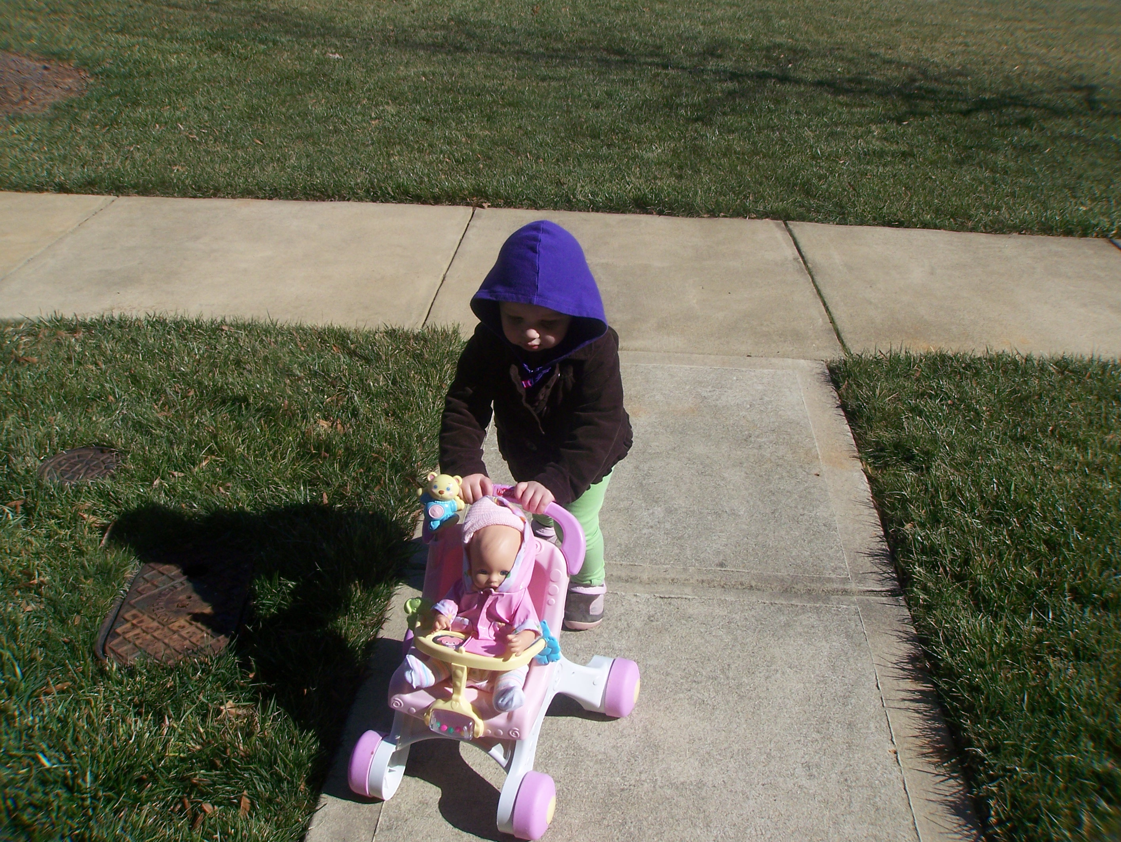
Used with permission. TW Moore, 2012
Self-Efficacy in Action

Students with a strong sense of self-efficacy:
- Perceive difficult tasks as challenges to be met and mastered; put forth considerable effort.
- May develop deeper interest in, and stronger commitment to, the activities in which they participate.
- Bounce back more quickly from letdowns. They learn from failures and try again.
- Are more likely to be intrinsically motivated.
- Attribute failure to factors within their control.
- Are likely to be successful in achieving their personal goals.
Students with a weak sense of self-efficacy:
- May avoid challenging tasks and perceive them as threatening.
- Are likely to not put forth a strong effort and give up easily.
- Express frustration, lack of confidence, and anxiety in behavior and words.
- Are reluctant to try again.
- Blame external factors for their lack of success.
- Have a pattern of disappointing academic performances.

“I’ve missed more than 9,000 shots in my career.
I’ve lost almost 300 games.
26 times I‘ve been trusted to take the game-winning shot…and missed.
I’ve failed over and over and over again in my life. That is why I succeed.”
- Michael Jordan

Students who have a solid belief that they are capable of performing assigned academic tasks use more cognitive and metacognitive strategies than those who do not. Self-efficacy has been shown through education research to have positive associations with self-regulation and success with in-class seatwork, homework, tests, quizzes, essays, and reports (Pajares, 2005). Historically, intelligence test scores have been the most powerful predictor of cognitive achievement. But, more recently, researchers discovered that self-efficacy makes a significant contribution to predicting academic achievement, separate from intelligence alone (Pajares, 2005).

It is widely reported that, when asked if he had ever been lost in the wilderness, Daniel Boone replied, “No, can’t say as I was ever lost. But, I once was bewildered for about three days.”

Self-efficacy begins to form early as children deal with a wide variety of experiences, tasks, and situations. Its growth and change does not end with adolescence, but continues throughout adulthood as we acquire new skills, understandings, and experiences (Bandura, 1992). According to Bandura (1992), there are four major sources of self-efficacy development:
1. Mastery Experiences
“The most effective way of developing a strong sense of self-efficacy is through mastery experiences” (Bandura, 1992). Some children say, “I got an A on my test because I am smart and I know how to study.” And, some children say, “I got an A on my test because I got lucky – the test was easy and the teacher gave everybody good grades.” What makes the difference? Children who believe that they did well because they are smart and they studied attribute their successes to factors having to do directly with them (internal factors), that are consistent about them (stable factors), and that are likely to play a role in most things they attempt (global factors). Children who believes that they did well on a test because of luck attribute their successes to factors out of their control (external factors), that may or may not occur (unstable factors), and that likely play an inconsistent role in most everything thing they attempt (specific factors). Dr. Frank Pajares (2005), distinguished professor of education and psychology at Emory University from 1994 until his death in 2009, offers the following strategies to enhance mastery experiences:
  - Emphasize skill development. Within a content area, start the student with an activity matched to their current competency leve. Challenge, don’t overwhelm. Coach the student through a concrete plan of attack. After success at a step towards problem-solution, review with the student the actual thoughts and behaviors that led to success.
  - Support self-regulation. Initially guide the student’s actions and gradually withdraw support as he or she achieves success. Re-direct, re-focus, and re-energize as necessary. Incorporate hands-on activities and projects.
  - Set goals with the student. Make sure the goals are short-term. It is not necessary to put the long-term goal in front of the student; successful completion of the short-term ones (objectives) will take care of the long-term one.
  - Provide feedback and encouragement. Maximize the impact of the mastery experience by providing honest feedback and genuine encouragement all along the way. Encourage accurate attributions by informing them that they succeeded because of their use of their own problem-solving ability, not because of luck or outside help.
Reflection: Think of an important skill you mastered as a child (riding a bike, playing a team sport, speaking a different language). Was it frustrating to learn this skill? Did you experience many failures? Who “helped” you and was it truly helpful?

2. Social Modeling/Comparisons
Observing someone similar to oneself work diligently to master a task or remove an obstacle to success can contribute to one’s belief that he/she can also achieve in that environment. For example, if a first-grader, Ginny, sees her friend, Amber, climb the steps of the tall slide and go down, she may think, “If Amber can do that, I can, too”. To enhance this source of self-efficacy development, use the following strategies:
- Pair with models; place in a group. The more similar the student feels to his or her paired partner, the stronger the effect the other student’s successes or failures will be on the target student’s beliefs about their own ability to succeed. In grouping, place the student in a work-group with others of similar skill-level and that includes at least one student performing at a slightly higher level. Group dynamics are powerful. Take care to not create a group in which one or two students monopolize, or one in which a student is likely to feel socially or academically disadvantaged. Effective grouping requires teachers to know their students well.
- Be a model. Good-naturedly admit errors when they are pointed out or when you catch them yourself. (“Oh, I didn’t get that right. Thanks for helping me out!”) Encourage students to accept that everyone makes mistakes and that they can be corrected. “Perfect” adults leave children with the impression that making errors is unacceptable and a characteristic of only people who are stupid.
- Play-down comparisons. Students will do enough comparing on their own. Encourage the development of individual internal standards for each student to evaluate their own outcome. A regular, very brief, private progress meeting with a student can give the opportunity for the teacher to remind the student where he or she was and the progress made to the current moment. The teacher’s goal is to help the student develop internal standards that are “rigorous without being debilitative, realistic without being self-limiting, fluid without being wishy-washy and consistent without being static.” (Pajares, 2005).
Reflection: What skill did you develop interest in and learn to master because you observed an older relative’s ability? Was there an adult model in your child environment that gave you the impression that they never made a mistake? What was it like to be around them?

3. Social Persuasion
The third source of self-efficacy comes from the verbal messages and social persuasions one receives. Verbal and non-verbal communications to a child play a vital role in the child’s development of self-confidence and even become the self-talk that children may use for years to come (Pajares, 2005). Cruelly, it is the child who has the lowest confidence in his or her abilities that is likely to be the most affected by discouragements and negative responses.
Careful the things you say;
Children will listen.
Careful the things you do;
Children will see and learn.
Children may not obey, but children will listen.
Children will look to you for which way to turn;
Co-learn what to be.
Careful before you say 'Listen to me’;
Children will listen.
-Stephen Sondheim
The following strategies are suggestions for appropriate social persuasion:
- Give feedback to students that is positive, appropriate to the task at hand, and, importantly, genuine and realistic. Children quickly recognize false praise. Artificial inflation is manipulative, dishonest, destroys a teacher’s credibility, and does not influence self-efficacy. “Process praise” reinforces students for their efforts and the successful strategies used, for example, “You did well because you did not give up, even though you were frustrated, and you tried different ways until you solved the problem.”
- Foster beliefs that skill can be learned and that it is changeable and controllable. Encourage effort, perseverance, and persistence. Use examples with students as to how you, the teacher, or others overcame obstacles. The website http://www.des.emory.edu/mfp/OnFailingG.html has some interesting brief examples of how highly accomplished and respected individuals struggled but did not give up.
- Make a memorable moment by providing a student with private, genuine, positive feedback. This sort of moment can make a powerful, lasting, and sustaining impression.
- Be aware of unintended messages that might be sent to students. For example saying, “Well, I had a hard time with math, too, and so did my sister; sometimes it just runs in families!” gives the student permission to not be concerned about their understanding of math! They might stop their efforts to improve. Especially maintain awareness of lack of confidence experienced by girls in the content areas of math and science and address promptly.

4. Physiological and Emotional States
Stress, anxiety, fatigue, arousal, and mood play an important role in self-efficacy (Bandura, 1994). Positive emotional states support perceptions of efficacy, and likewise, negative ones break down a sense of efficacy. With positive emotion, an “upward spiral” can be created that promotes a student’s ability to see more solutions to problems, which strengthens their positivity, which then further enhances their ability to cope, and so on. Upward spirals such as this can result in strengthening students’ perception that they can effectively control their environment (National Association of School Psychologists, 2010). The following strategies can make a positive impact on the physiological and emotional states that reduce self-efficacy:
- Help students learn to “read” their feelings (Pajares, 2005). Stress and agitation almost ensure less-than-successful problem-solving, and anxiety and dread can be paralyzing. Teach students to discuss the above feelings with you or a counselor; exploring why the feelings occur, how to interpret them, and how to minimize their impact. Attempt to lower anxiety surrounding tests and presentations.
- Help the student identify strategies that are not helpful and are, in fact, handicapping their efforts. A very common self-handicapping strategy is to not put forth much effort in a task in which the student believes they will fail anyway. This maladaptive coping mechanism reduces stress for students momentarily who then can tell themselves that they failed because they didn’t really try, and that they could do well if they wanted to. The result of this sort of self-deception leads to lower and lower confidence, missed opportunities, and a vicious cycle of continued failure.
- Encourage and model optimism. As Bandura (1994) has observed, people primarily create their own psychological environment. Optimism (the expectation of positive outcomes) can be cultured in a classroom and with individual students, and its power is increased if modeled by the teacher. In the scientific literature, optimism has been shown to be positively correlated with less fatigue and physical complaints, better academic and social adjustment, and higher goal commitment (Montgomery, Haemmerlie, & Ray, 2003).
Reflection: To which academic subject did you most react with anxiety and fear when you were an elementary school student? What did your teacher(s) do that increased or decreased this anxiety? How do you react to this skill area today when some situation requires that you call upon it?

Example: The following is an example of interaction with a student that encompasses all four sources of self-efficacy beliefs.
Jana, a student with weak self-efficacy in the area of math, demonstrates great reluctance to raise her hand or go to the board to work during math class. When she is asked to speak in class about a math solution, her face gets red, she lowers her head, and seems immobilized (psychological state of anxiety and nervousness).
Mrs. Mabry, Jana’s teacher sees an opportunity to help Jana improve her self-efficacy. She states to Jana, “If you would let me, I’d like to work with you on your comfort level with math. I really believe you can improve. Remember how well you have done with writing and reading comprehension, and you did a fine job of handling and calculating the tokens collected for the school bazaar. I believe you could do the same with the math we are covering now (positive feedback).
Mrs. Mabry paired Jana with another female student having similar hesitations with math. With the teacher’s coaching, the two began working on explaining to each other out loud how to approach different types of problems. Then, the two girls joined a larger group where each member practiced writing out problems on a small whiteboard for each other member to see and comment on (peer modeling).
After a couple of weeks, Jana and her teacher reviewed together her progress, what had improved, and what needed continued strong effort (feedback).
Jana was beginning to speak up more and more in her small group and actually demonstrate problem-solving on the whiteboard to the other group members (successful experience).

QUIZ, PART II: SELF-EFFICACY
1. Self-efficacy has to do with
- Global beliefs about likeability.
- Beliefs about competency.
- Ability to manage stress.
- An overall evaluation of the self.
2. Which of the following statements is true?
- Self-efficacy is unchangeable.
- Self-efficacy is not particularly important to success.
- Self-efficacy can be influenced.
- Self-efficacy is inherited, not learned.
3. The most effective way of increasing a student’s sense of self-efficacy is through encouraging
  - Others to use persuasion to convince the student of their own ability.
  - Mastery by using step-by-step problem-solving procedures.
  - Optimism in the class and in the individual student.
  - Giving genuine and specific feedback.

4. In using “grouping” to provide social modeling for a student of weak self-efficacy, make sure the group he/she is assigned to
- Have others at generally the same academic level.
- Includes two or three strong leaders.
- Is much different so the student can make strong comparisons.
- all of the above
5. Which message below might positively influence a student with weak self-efficacy?
- “Your sister was just like you! I guess it’s a family trait!”
- “There’s no need to be anxious; you’ll do fine now.”
- “Well, a lot of girls especially don’t do well in math.”
- “Describe that strategy you just used; it seemed to have worked well.”

END OF MODULE COMPONENT

