Setting SMART Goals with Students

SMART Goals Setting SMART Goals with Primary Students

S = Specific S = Say *exactly* what you want to accomplish

M = Measurable M = How will be able to tell you’ve accomplished this goal?

A = Attainable A = You can reach this goal

R = Results Based R = What will you do to reach this goal/get results?

T = Time Bound T= By….

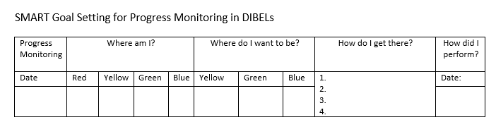

My SMART Goal is:____________________________________________________________

* The teacher fills in the date of the progress monitoring.
* The student colors in the box that corresponds with the results and the goal.
* The student writes what s/he will do to reach the next benchmark.
* Student writes the actual SMART goal.
  + may want to include places for student/teacher/parent signature
* After the next round of progress monitoring, the teacher provides the date and the student colors in the box with the appropriate color.