Efficacy Intervention: <http://www.gifted.uconn.edu/siegle/selfefficacy/section8.html>

**Need to discuss with team:**

You have the Integrating Assessment into Instruction document – Where should that go in the mini module? Once this is determined, please provide text to explain the information on the chart and if you want to use a Voki

· *The diagram is a “big picture” of assessment cycle in classrooms. The guiding questions in the top left and right corners are guiding questions for teachers and students. Including the questions for students reminds us that students could be involved in assessments beyond just being assessed.*

Please provide the links for: (You will need to provide some text that may explain when these links should be used or you can provide text to include the links so the learners can link to them when they need them).

· *I don’t know if these links* should *be included. I think the role of these data sources needs to be discussed before being placed in the final version of the module.*

* [EVAAS](https://ncdpi.sas.com/) to access your EVAAS data, and [EVAAS Resources](http://www.dpi.state.nc.us/effectiveness-model/evaas/resources/) to how to use various reports.
* RTI: lots of information about how to use student data for the teacher to set individual student goals
* mClass: See RTI (benchmark progress for monitoring data
* NC Professional Teaching Standards (2C, 3D,4B, 4C, 4E, 4H, 6) from rubric starting on page 21 of [Teacher Evaluation Manual](http://www.ncpublicschools.org/docs/effectiveness-model/ncees/instruments/teach-eval-manual.pdf)

**Added 1/17/14**

Connection to NC Professional Teaching Standards: Standards **IIC**; **IIId**; **IVb**; IVc; IVe; **IVh**; VI;

EVAAS, RTI, mClass are all sources of data to analzye and help students set meaningful and relevant goals.

Connection to EVAAS:

Connection to RTI:

Connection to mClass: benchmark and progress monitoring data

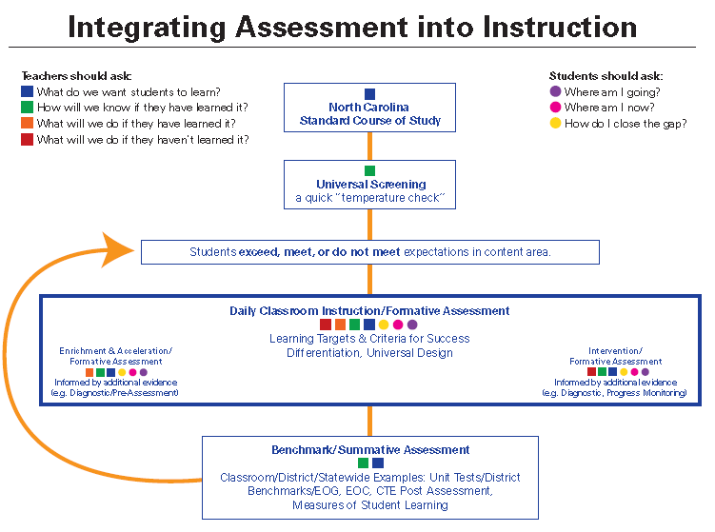

Setting SMART Goals with Students

SMART Goals Setting SMART Goals with Primary Students

S = Specific S = Say *exactly* what you want to accomplish

M = Measurable M = How will be able to tell you’ve accomplished this goal?

A = Attainable A = You can reach this goal

R = Results Based R = What will you do to reach this goal/get results?

T = Time Bound T= By….

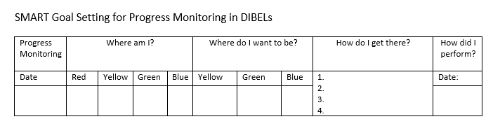

My SMART Goal is:____________________________________________________________

* The teacher fills in the date of the progress monitoring.
* The student colors in the box that corresponds with the results and the goal.
* The student writes what s/he will do to reach the next benchmark.
* Student writes the actual SMART goal.
  + may want to include places for student/teacher/parent signature
* After the next round of progress monitoring, the teacher provides the date and the student colors in the box with the appropriate color.

OR

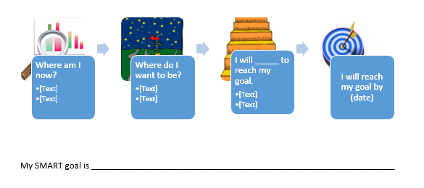

OR

|  |  |  |  |  |
| --- | --- | --- | --- | --- |
| What do I want to improve on in school? | What will be different when I make improvements? | What will I do to make improvements? | How long will it take me to make improvements? | Did I improve? |
|  |  |  |  |  |
|  |  |  |  |  |
|  |  |  |  |  |
|  |  |  |  |  |

My SMART Goal is _______________________________________________________________.

Inspired by

<http://online.wsj.com/news/interactive/docid=110308210117-c6b57554c1f84d16849adff5600747ee%7Cfile=workfam0308lamarque1?ref=SB10001424052748704758904576188453057819300>

and

<http://online.wsj.com/news/interactive/docid=110308212723-1da154057ec24c3c80acaf0a9823173a%7Cfile=workfam0308-2sikes?ref=SB10001424052748704758904576188453057819300>