Transcripts for Slides and Voki

Obj. 1.1 SMART Goals Introduction

Slide 1 |  | What are SMART Goals? Why are they important?
Slide 2 |  | Consider this excerpt from Lewis Carol’s Alice adventure in Wonderland. If you know where you want to be and what to do to get there, the chances of success are greater. Articulating where we want to be in the future and mapping out a plan for getting there reflects commitment and a desire to succeed.
Slide 3  Slide 4 | 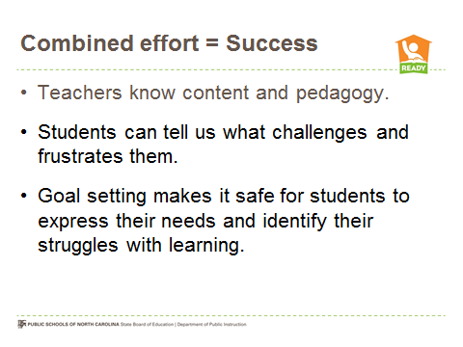 | The development of SMART Goals is the construction of a powerful, living plan to improve student achievement that has meaning, and is focused on teacher growth that leads to increased student success.  SMART is an acronym.
Slide 5 | 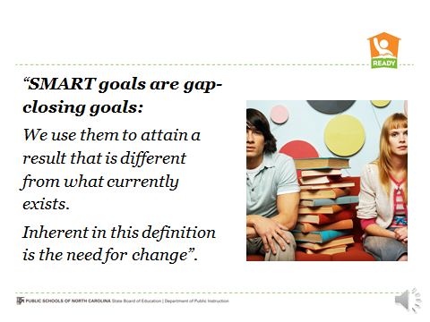 | The authors of The Power of Smart Goals: Using Goals to Improve Student Learning highlight the benefits of developing SMART Goals. Take a moment to reflect on their thinking.
Slide 6 | 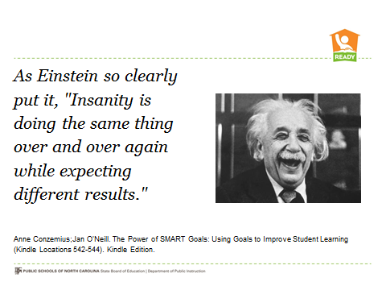
Slide 7 | 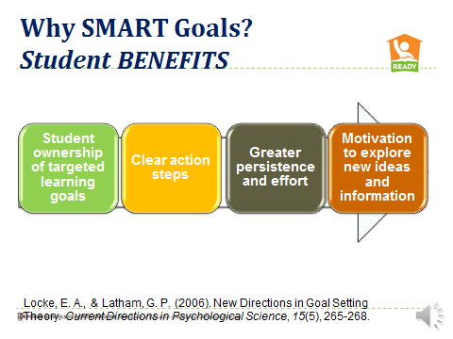 | Locke and Latham suggest that effective goal setting results in greater professional growth which leads to increased success for students. A strong goal setting process also generates more focused effort, persistence and determination to succeed for individuals and teams. Carefully planned data-driven goals may also increase one’s personal motivation to seek new knowledge, strategies and information since they are data-driven and not “assigned” because of personal preferences. Buy-in to goals is important. Otherwise, goals sit on a shelf unattended and forgotten.
Slide 8  Slide 9 | 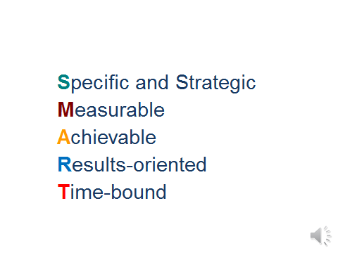  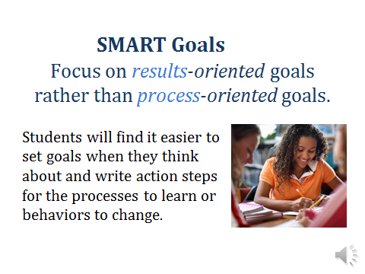 | So again to summarize SMART Goals are:  Specific and Strategic  Measurable  Achievable  Results-oriented and  Time-bound  Process goals are really action steps that could support a results-focused SMART Goal. A goal stated in process terms emphasizes an activity, event or program that may be implemented to help reach a results-oriented goal and increase learning.  When drafting a goal, a focus on results rather than process, leads to clarity in actions and effective steps towards attainment of the goal.  A Results focused example could be:  Communication efforts will increase from one contact each month to two per month as indicated by emails, phone call logs and posted wiki messages.
Slide 10 |  | SMART Goals are Specific and Strategic
Slide 11 |  | SMART Goals are measurable. Smart Goals use data to determine how successful we are in reaching our goals.  We might use EOG or EOC data for example and establish expected ranges of improvement.
Slide 12 |  | SMART Goals are Achievable.  •The result can be reached, even if it is a stretch goal.  •The goal is worthy of an educator’s commitment of time and effort.  •A stretch goal might be one that requires an intense plan of work and action steps in order to be achievable.  •We know we will do whatever it takes to ensure that students learn once we set this goal.
Slide 13 |  | •Goals are set based on need and data that reveal targets for teacher, administrator and student growth.  •Support along the way, throughout the year make the goals real and alive. We pay attention to that which is important. Goal writing is a process that allows for self-reflection and setting targets that guide an individual’s professional development. The goals are measurable and require us to focus on results and reflect on our progress towards attainment of the SMART goal.  •We reach for stretch goals that are attainable, reasonable and realistic, time-bound, and focused on big results.
Slide 14 |  | SMART Goals are time-bound  Goal setting must include a plan to “progress monitor” throughout the school year. The professional development plan is reviewed at the beginning of the year, the middle of the year and the end of the year for “progress monitoring”.  While the review points are set for a mid-year and end of year review of the PDP, the individual SMART goals may set more frequent benchmarks for progress monitoring. For example – 5 weeks, 10 weeks, quarterly, etc.
Slide 15  Slide 16 | 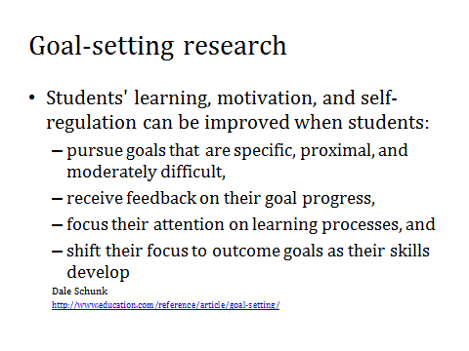  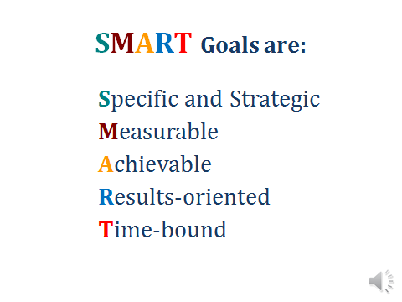 | Again, to summarize;  SMART Goals are:  Specific and Strategic  Measurable  Achievable  Results-oriented  Time-bound

Voki Transcript – How do students write SMART Goals

Now that you have practiced writing SMART Goals, let’s consider writing SMART goals with students. When we conference with students or work with them on classroom tasks, students can usually tell us what they struggle with and what comes more easily for them. Those conversations create an opportunity to develop SMART goals with students.
Teachers may wish to set SMART Goals with students for several reasons.
The Partnership for 21st Century Skills included setting learning goals as one way to develop “Life and Career Skills”, (the Partnership for 21st Century Skills, P21).

McTighe and O’Connor saw goal-setting as a habit of mind of “the most effective learners” and included goal setting as one of seven practices for effective learning (McTighe & O’Connor, 2005).

Setting goals gives direction to student work and provides an opportunity for students to see meaningful progress in their academic work (Siegle, 2000). In short, setting and meeting academic goals is one way to boost confidence and motivate students.

Resources and Strategies for supporting students in Implementing, Evaluating, Revising and accomplishing their SMART Goals

Slide 1
Slide 2 | 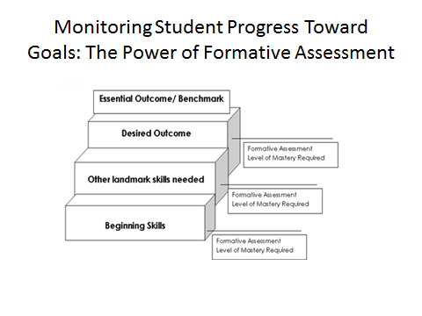 | Writing student SMART goals begins with the end or essential outcome in mind. It becomes important that you support students in designing action steps toward meeting their goal using data gained from formative assessments. To do so, you will need to consider the skills that will be necessary for students to reach their essential outcome/benchmark. Mapping out the progression of skills that will be needed to reach the goal is essential and will help to provide the supports and interventions that are necessary for students to meet their academic goals.
Slide 3 | 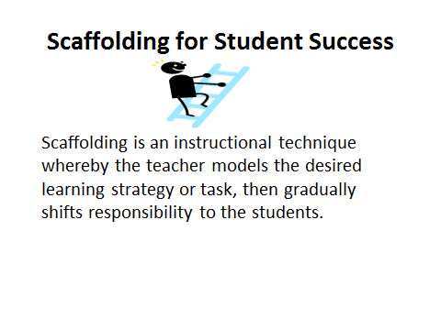 | Similar to the scaffolding used in construction to support workers as they work on a specific task, instructional scaffolds are temporary support structures faculty put in place to assist students in accomplishing new tasks and concepts they could not typically achieve on their own. Once students are able to complete or master the task, the scaffolding is gradually removed or fades away—the responsibility of learning shifts from the instructor to the student.  The need to implement a scaffold will occur when you realize a student is not progressing on some aspect of a task or unable to understand a particular concept. Although scaffolding is often carried out between the instructor and one student, scaffolds can successfully be used for an entire class.
Slide 4 | 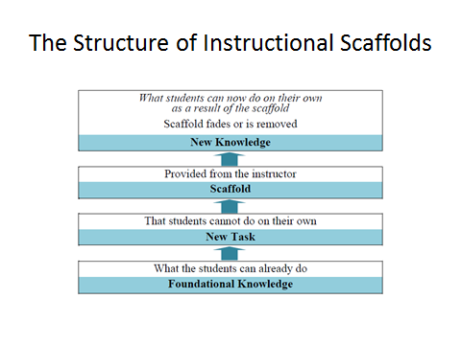 | Instructional scaffolds promote learning through dialogue, feedback and shared responsibility. Through the supportive and challenging learning experiences gained from carefully planned scaffolded learning, instructors can help students become lifelong, independent learners.
Slide 5 | 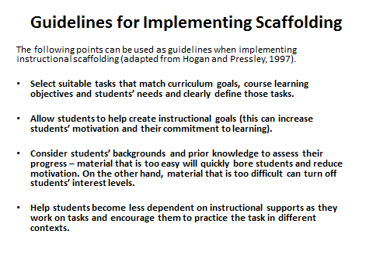 | Please take a moment to read each of these guidelines. These points can be used as guidelines when implementing instructional scaffolding. These points have been adapted from Hogan & Pressley. Once you have completed the guidelines, you will find additional resources on the reference page at the end of this presentation.
Slide 6 | 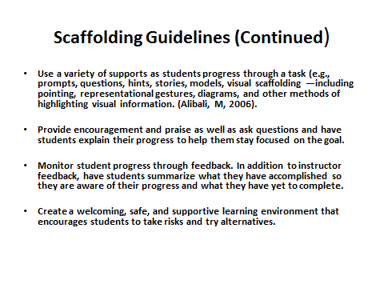 | These are additional guidelines.
Slide 7 | 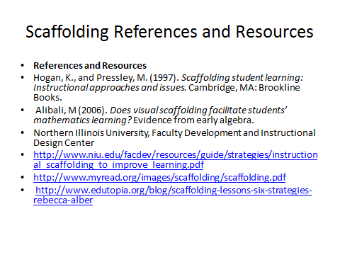

Supporting Students in Identifying Obstacles to Reaching Goals

Slide 1 | 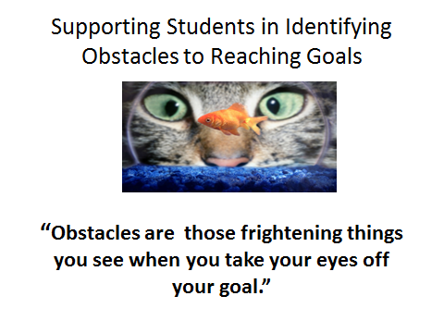 | Obstacles can be anything or anyone that gets in the way of a student reaching his or her goals. Helping students realize that there will likely be obstacles along the path to their goal makes it easier to plan for, overcome or avoid them.
Slide 2 | 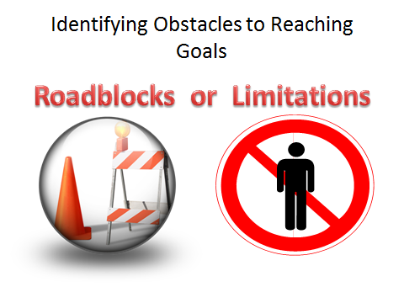 | Obstacles can come in two forms: roadblocks and real limitations. A roadblock is an obstacle which you have the power to control. Many roadblocks are very real and cannot be changed or removed - these are called limitations.  It is important that we develop students’ understanding in that many opportunities lie in areas which you CAN change. It is important for students to be able to decide whether the roadblock is a true limitation, something that they are unable to change, or not. Accepting any limitations requires them to be really honest with themselves and they may need assistance in adjusting their goals accordingly. Help them to not waste energy on things they can't change at the time.
Slide 3 | 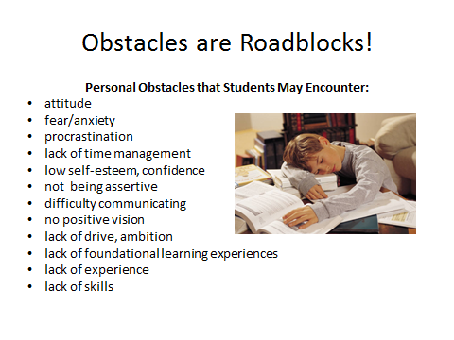 | Identifying potential obstacles can help you help students plan ways to deal with them. Roadblocks can be listed in two categories: personal obstacles and external obstacles. Here are a few examples each. Please allow time for reading the next 2 slides.
Slide 4 | 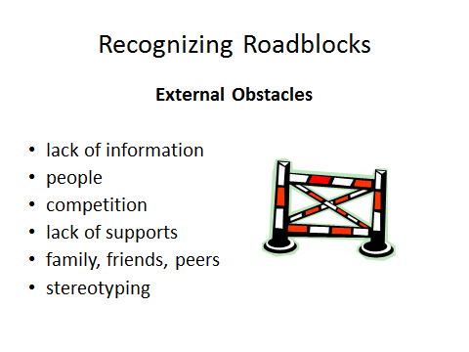
Slide 5 | 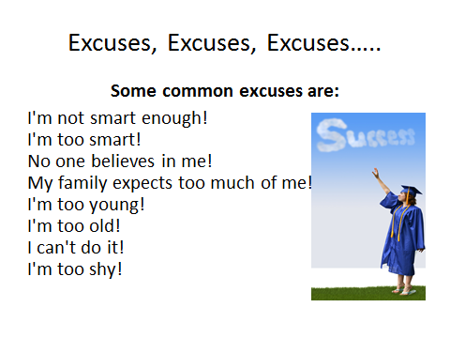 | Excuses are another form of roadblock. Consider having this conversation with your students: Have you ever said: "I can't do it because....?" Most people are very creative in thinking up reasons for not following through. The question is, how valid are your reasons?  Excuses make it easier to give up on a goal. By making excuses you give up responsibility for your goal and the problem is never solved.
Slide 6 | 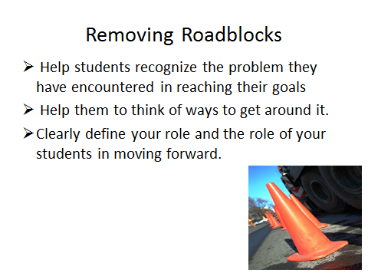 | Before your students can remove a roadblock, they have to recognize the problem. You are responsible for directing your own life and solving your own problems. Once you take responsibility for the roadblock, you will be able to think of ways to get around it. Often people give up for the wrong reasons, usually fear or anxiety. Everyone has anxieties. This is a normal part of setting goals and trying to reach them. It becomes very important to find a way to overcome the feelings you experience when you are anxious.
Slide 7 | 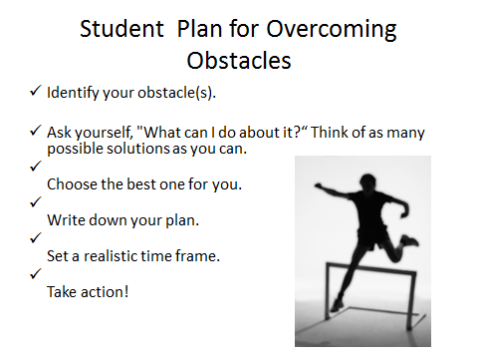 | Use this framework for engaging in a conversation with your students:  - Identify your obstacle(s).  - Ask yourself, "What can I do about it?“ Think of as many possible solutions as you can.  - Choose the best one for you.  - Write down your plan.  - Set a realistic time frame.  - Take action and adjust depending on age level.

